User Manual for PokeDodge

To play our game, you must first open the Game11.fla file by going to Chau & Nguyen \ Releases \ V2.1. Once the Game11.fla is loaded, press CTRL + ENTER to start the game up. (Picture indicates Game10 but it’ll be the same for Game11)

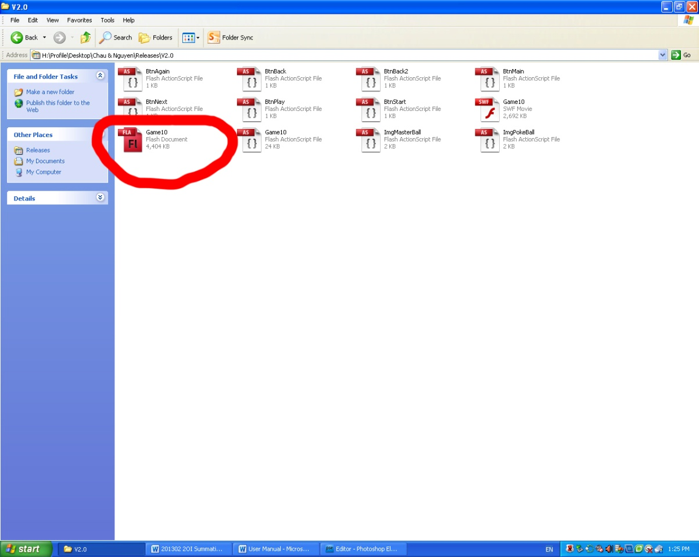

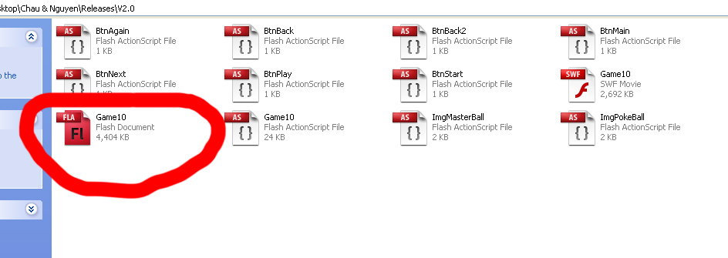

Once the game is started up, you should be at the main screen. Press the “Start!” button in order to proceed to the next screen.

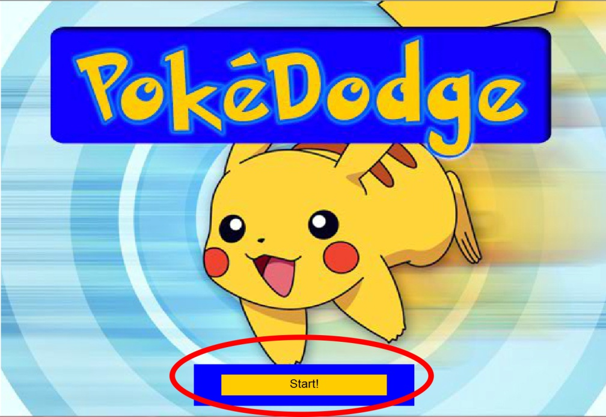

The next screen is the instruction screen. Read the instructions in order to understand the game (1). If you wish to go back to the previous screen, press the “Back” button (2). Once you’re finished reading the instructions and wish to continue, press the “Next” button (3).

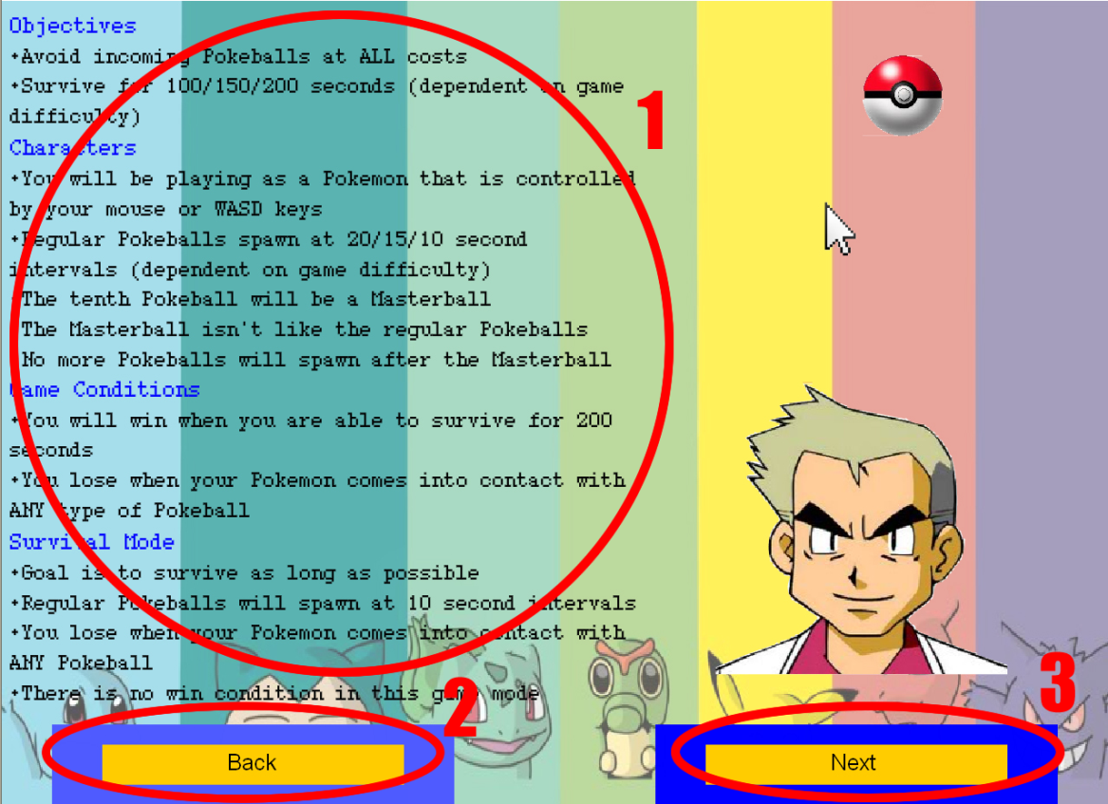

The screen that you should now be seeing is the options screen. Here on the options screen, you have the ability to modify several things about PokeDodge. You can change the amount of players playing from single to two or vice versa (1). You are able to switch between classic mode and survival mode (2). You can switch between the three difficulties: normal, hard and insane. The normal difficulty has balls spawning at 20 second intervals and move at a moderate rate. The hard difficulty has balls spawning at 15 second intervals and move at a fast pace. The insane difficulty has balls spawning at 10 second intervals and move at an INSANELY fast rate (not really). You have the option of choosing which Pokemon you will be playing as (the Pokemon do not differ in any way other than aesthetics) (4). Finally, you can choose between controlling the Pokemon with the mouse or WASD (5). The options are defaulted to single player, classic mode, normal difficulty, Pikachu, and mouse. If you wish to go back to the previous screen, press the “Back” button (6). If you wish to continue and start playing the game, press the “Play” button (7).

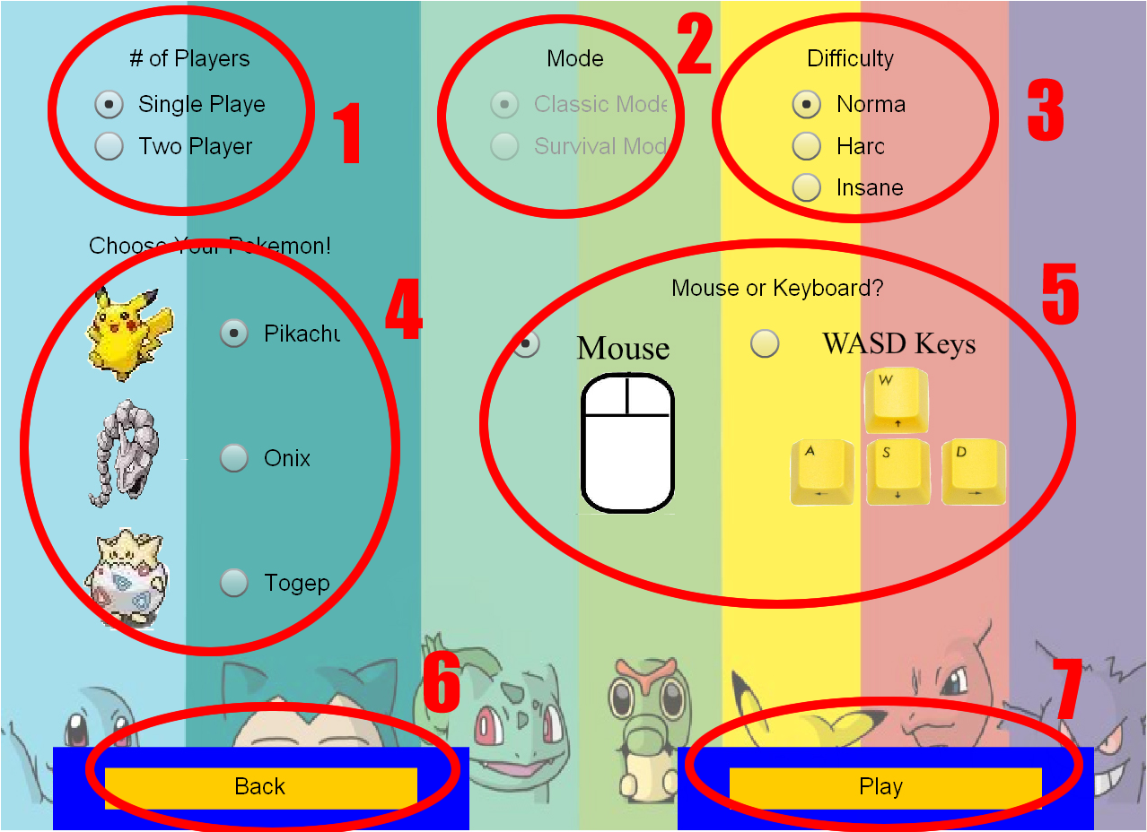

After pressing the “Play” button, you should now be in game. On the screen you should see your Pokemon which will either be controlled by your mouse or WASD (1). Your objective is to avoid the Pokeballs that are constantly spawning on the screen (2). Up in the top left corner there is a timer counting down the amount of seconds until the next ball will spawn (3). Beside that there is your health (4) and beside that is a counter that shows how many balls are currently on the screen (5).

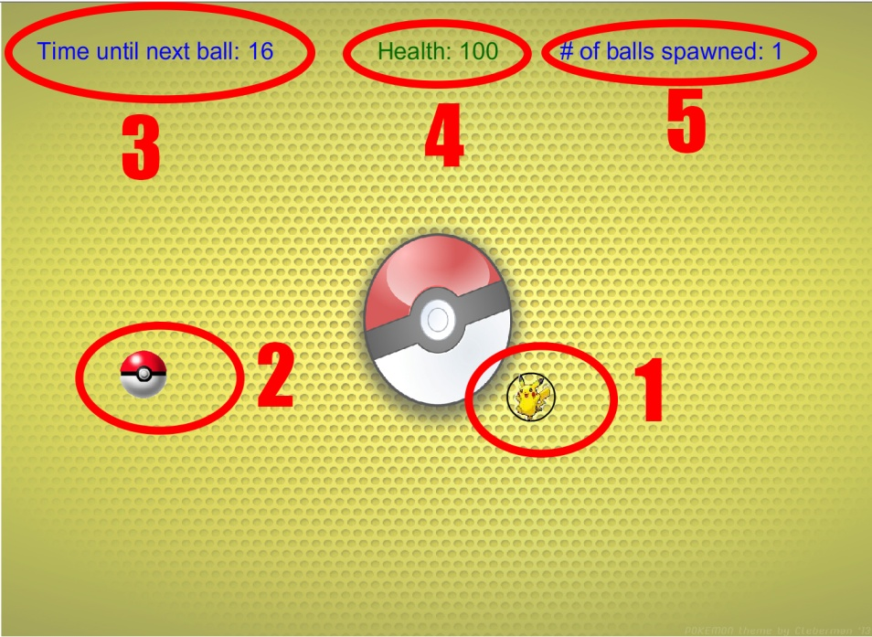

When you come into contact with a Pokeball (1), your health will start to flash red and decrease (2). The longer you stay on top of a Pokeball, the more rapidly your health will decrease.

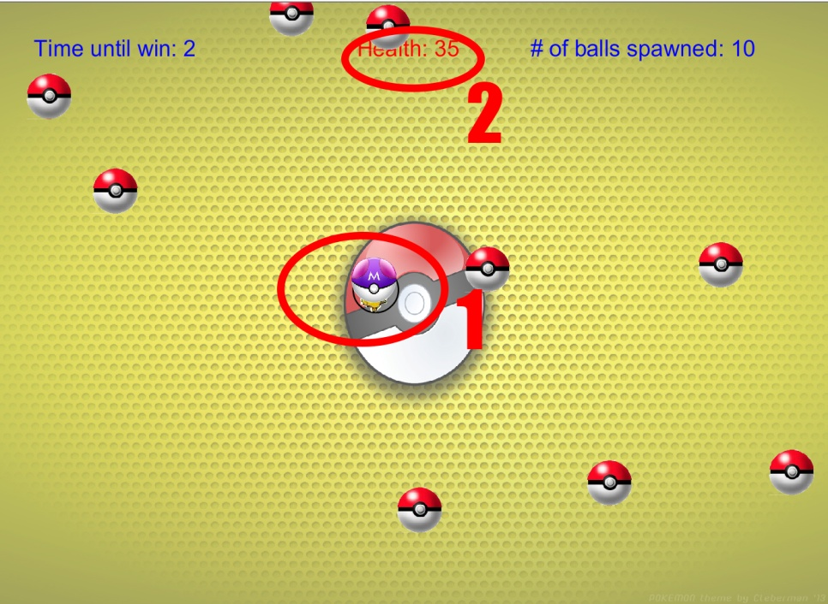

If you take too much damage and your health hits 0, you will essentially lose the game and be sent to the lose screen. From here you have two options; you can try again by pressing the “Play Again?” button (1) or if you feel like changing the options or rereading the instructions, press the “Main Menu” button (2).

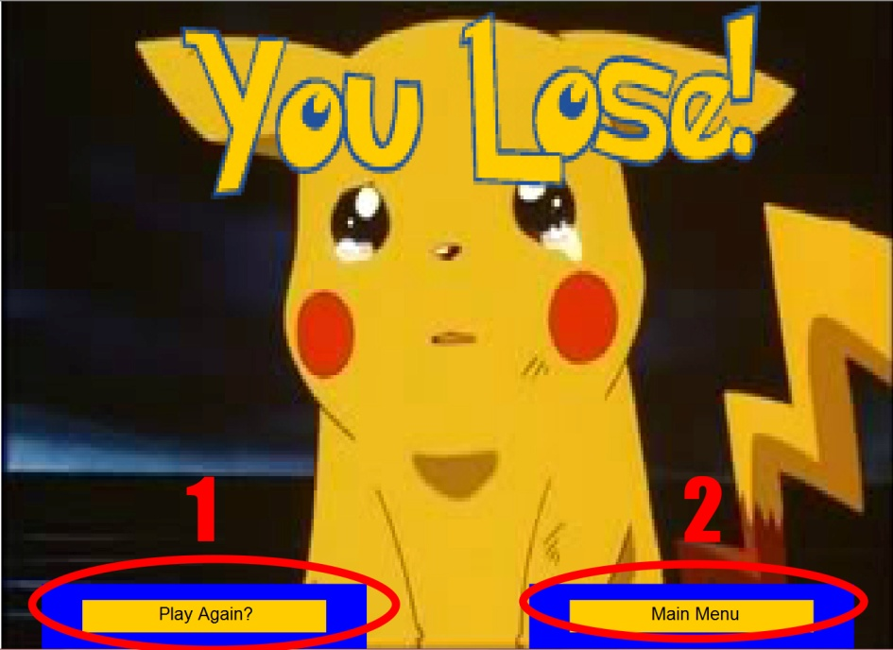

If you manage to survive for the set amount of time, you will win the game and be sent to the win screen. From here you have two options; you can try again by pressing the “Play Again?” button (1) or if you feel like changing the options or rereading the instructions, press the “Main Menu” button (2).

